**Questions & Answers**

**Q1) Which of the following is the correct order of occurrence in a typical SQL statement?**

A. select, group by, where, having

B. select, where, group by, having

C. select, where, having, group byselect, having, where, group by

D. select, having, where, group by

**Solution:**

Database executes query components in this order: SELECT, FROM, WHERE, GROUP BY, HAVING, ORDER BY.

**Question Context: 2 to 12**

**STUDENT**

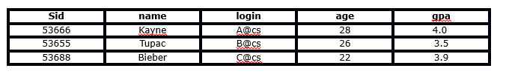

**ENROLLED**

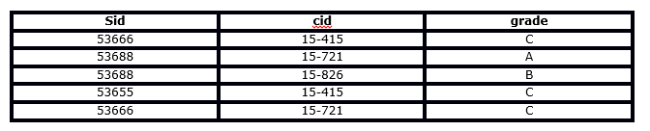

**Q2) Which of the following is the correct outcome of the SQL query below?**

Query: SELECT cid FROM ENROLLED WHERE grade = 'C'

A. Extract the course ids(cid) where student receive the grade C in the course

B. Extract the unique course ids(cid) where student receive the grade C in the course

C. Error

D. None of these

**Solution:**

The query will extract the strings where grade = “C” and get theirs cid (course_id?).

**Q3) Which of the following is the correct outcome of the SQL query below?**

Query: SELECT DISTINCT cid FROM ENROLLED WHERE grade = 'C'

A. Extract the course ids where student receive the grade C in the course

B. Extract the Distinct course ids where student receive the grade of C in the course

C. Error

D. None of these

**Solution:**

By using DISTINCT you can extract the distinct course ids where student’s grade equal “C”.

**Q4) Which of the following is the correct outcome of the SQL query below?**

Query: SELECT name, cid FROM student, enrolled WHERE student.sid = enrolled.sid AND enrolled.grade = 'C'

A. Returns the name of all students and their corresponding course ids

B. Returns the name of students and their corresponding course id where they have received grade C

C. Error

D. None of these

**Solution:**

The above query first joined the ENROLLED and STUDENT tables then it will evaluate the WHERE condition and then it will return the name of students and corresponding course id where they grade is “C”.

**Q5) Which of the following is the correct outcome of the SQL query below?**

Query: SELECT student.name, enrolled.grade FROM student, enrolled WHERE student.sid = enrolled.sid AND enrolled.cid = '15-415' AND enrolled.grade IN ('A', 'B')

A. Returns the name, grade of the students who took course ’15-415′ and got a grade’ A’ or ‘B’ in that course

B. Returns the name, grade of the students who took the course ’15-415′ but didn’t get grade ‘A’ or ‘B’ in that course

C. Error

D. None of these

**Solution:**

Query first joined the ENROLLED and STUDENT tables then it will evaluate the where condition and then it will return the name, grade of the students, those took 15-415 and got a grade 'A' or 'B' in the course. But for the given two tables it will give zero records in output.

**Q6) Which of the following query will find all the unique students who have taken more than one course?**

A. SELECT DISTINCT e1.sid FROM enrolled AS e1, enrolled AS e2 WHERE e1.sid != e2.sid AND e1.cid != e2.cid

B. SELECT DISTINCT e1.sid FROM enrolled AS e1, enrolled AS e2 WHERE e1.sid = e2.sid AND e1.cid = e2.cid

C. SELECT DISTINCT e1.sid FROM enrolled AS e1, enrolled AS e2 WHERE e1.sid != e2.sid AND e1.cid != e2.cid

D. SELECT DISTINCT e1.sid FROM enrolled AS e1, enrolled AS e2 WHERE e1.sid = e2.sid AND e1.cid != e2.cid

**Solution:**

Query D will first apply self join on enrolled table and then it evaluate the condition e1.sid = e2.sid AND e1.cid != e2.cid.

**Q7) Which of the following statement will add a column ‘F_name’ to the STUDENT table?**

A. ALTER TABLE Student add column ( F_name varchar(20));

B. ALTER TABLE Student add F_name varchar(20);

C. ALTER TABLE Student add (F_name varchar(20));

D. ALTER TABLE Student add column (F_name);

**Solution:**

Opt B is correct syntax of ALTER to add a column in the table.

**Q8) Which of the following query(s) will result in a successful insertion of a record in the STUDENT table?**

Query1: INSERT INTO student (sid, name, login, age, gpa) VALUES (53888, ‘Drake’, ‘drake@cs’, 29, 3.5)

Query2: INSERT INTO student VALUES (53888, ‘Drake’, ‘drake@cs’, 29, 3.5)

A. Both queries will insert the record successfully

B. Query 1 will insert the record successfully and Query 2 will not

C. Query 2 will insert the record successfully and Query 1 will not

D. Both queries will not be able to insert the record successfully

**Solution:**

Both queries will successfully insert a row in table STUDENT.

**Q9) ‘Sid’ in “ENROLLED” table is ‘Foreign Key’ referenced by ‘Sid’ in “STUDENT” table. Now you want to insert a record into the ENROLLED table.**

Which of the following option(s) will insert a row in ENROLLED table successfully?

1. INSERT INTO ENROLLED values(53667, '15-420', 'C');
2. INSERT INTO ENROLLED values(53666, '15-421', 'C');
3. INSERT INTO ENROLLED values(53667, '15-415', 'C');
4. INSERT INTO ENROLLED values(53666, '15-415', 'C');

A. 1 and 3

B. Only 3

C. 2 and 4

D. Only 4

**Solution:**

Opt 2 and 4 will run successfully because in ENROLLED’s table 'Sid' column you can insert those values which are present in STUDENT's table 'Sid' columns due by foreign key.

**Q10) Consider the following queries:**

Query1: select name from enrolled LEFT OUTER JOIN student on student.sid = enrolled.sid;  
Query2: select name from student LEFT OUTER JOIN enrolled on student.sid = enrolled.sid;

**Which of the following option is correct?**

A. Queries 1 and 2 will give the same results

B. Queries 1 and 2 will give different results

C. Query 1 will produce an error and Query 2 will run successfully

D. Query 2 will produce an error and Query 1 will run successfully

**Solution:**

Both dependencies on records present in table and which column in selected.

**Q11) Which of the following statements will modify the data type of “Sid” column in ENROLLED table?**

**Note: There is no foreign key relationship between tables STUDENT and ENROLLED.**

A. ALTER TABLE ENROLLED MODIFY (sid varchar(100));

B. ALTER TABLE ENROLLED MODIFY sid varchar(100);

C. ALTER TABLE ENROLLED MODIFY column (sid varchar(100));

D. ALTER TABLE ENROLLED MODIFY attribute (sid varchar(100));

**Solution:**

ALTER TABLE MODIFY is used to modify column definition in a table. Opt A has correct syntax.

**Q12) Which of the following statement will remove the ‘Sid’ column from the ENROLLED table?**

**Note: There is no foreign key relationship between tables STUDENT and ENROLLED.**

A. ALTER TABLE ENROLLED DROP (sid varchar(10) );

B. ALTER TABLE ENROLLED DROP COLUMN (sid varchar(10) );

C. ALTER TABLE ENROLLED DROP COLUMN Sid;

D. ALTER TABLE ENROLLED MODIFY (sid);

**Solution:**

ALTER TABLE DROP COLUMN using to drop a column from the table.

**Q13) Which of the following command(s) is /  are related to transaction control in SQL?**

A. ROLLBACK

B. COMMIT

C. SAVEPOINT

D. All of the above

**Solution:**

All are related to transaction control in SQL.

**Q14) Which of the following is true for a primary key?**

A. It can take a value more than once

B. It can take null values

C. It can’t take null values

D. None of these

**Solution:**

In a relational schema, there exist only one primary key and it can't take null values.

**Q15) What is the difference between a primary key and a unique key?**

A. Primary key cannot be a date variable whereas unique key can be

B. You can have only one primary key whereas you can have multiple unique keys

C. Primary key can take null values but unique key cannot null values

D. None of these

**Solution:**

You can create a date variable as a primary key in table. In relational schema, you can have only one primary key and there may be multiple unique key present in table. Unique key can take null values.

**Q16) Which of the following statement(s) is/are true for UPDATE in SQL?**

1. You can update only a single table using UPDATE command
2. You can update multiple tables using UPDATE command
3. In UPDATE command, you must list what columns to update with their new values (separated by commas).
4. To update multiple targeted records, you need to specify UPDATE command using the WHERE clause.

Select the correct option:

A. 1, 3 and 4

B. 2, 3 and 4

C. 3 and 4

D. 1 only

**Solution:**

You can’t update multiple tables by UPDATE command.

**Q17) Which of the following is true for TRUNCATE in SQL?**

A. It is usually slower than DELETE command

B. It is usually faster than DELETE command

C. There is no comparison between DELETE & TRUNCATE

D. Truncate command can be rolled back

E. None of these

**Solution:**

TRUNCATE is faster than delete because it is a ddl command.

**Q18) Which of the following statement is correct about ‘CREATE TABLE’ command while creating a table?**

A. We need to assign a datatype to each column

B. We have flexibility in SQL. We can assign a datatype to column even after creating a table

C. It is mandatory to insert atleast a single row while creating a table

D. None of these

**Solution:**

Each column must possess behavioral attributes like data types and precision in order to build the structure of the table.

**Q19) Which of the following are the synonyms for ‘column’ and ‘row’ of a table?**

1. Row = [Tuple, Record]
2. Column = [Field, Attribute]
3. Row = [Tuple, Attribute]
4. Columns = [Field, Record]

Select the correct option:

A. 1 and 2

B. 3 and 4

C. Only 1

D. Only 2

**Solution:**

I don't know what to write here.

**Q20) Which of the following operator is used for comparing ‘NULL’ values in SQL?**

A. Equal

B. IS

C. IN

D. None of Above

**Solution:**

Likewise, the answer describes everything.

**Q21) Which of the following statement(s) is/are true about “HAVING” and “WHERE” clause in SQL?**

1. WHERE” is always used before “GROUP BY” and HAVING after “GROUP BY”
2. WHERE” is always used after “GROUP BY” and “HAVING” before “GROUP BY”
3. “WHERE” is used to filter rows but “HAVING” is used to filter groups
4. “WHERE” is used to filter groups but “HAVING” is used to filter rows

Select the correct option:

A. 1 and 3

B. 1 and 4

C. 2 and 3

D. 2 and 4

**Solution:**

HAVING is performed after GROUP BY. If you have to apply some conditions to get results. You need to use WHERE beforeGROUP BY.

**Q22) Identify, which of the following column “A” or “C” given in the below table is a “Primary Key” or “Foreign Key”?**

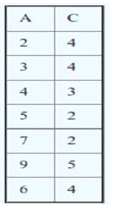

**Note: We  have defined ‘Foreign Key’ and ‘Primary Key’ in a single table**

A. Column ‘A’ is Foreign Key and Column ‘C’ is Primary Key’

B. Column ‘C’ is Foreign Key and Column ‘A’ is ‘Primary Key’

C. Both can be ‘Primary Key’

D. Based on the above table, we cannot tell which column is ‘Primary Key’ and which is ‘Foreign Key’

**Solution:**

Column A is taking unique values and doesn't have null values. So it can be considered as Primary key of this table.

**Q23) What are the tuples additionally deleted to preserve reference integrity when the rows (2,4) are deleted from the below table. Suppose you are using ‘ON DELETE CASCADE’.**

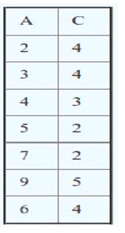

**Note: We have defined ‘Foreign Key’ and ‘Primary Key’ in single table**

A. (5,2) , (7,2), (9,5)

B. (5,2) , (7,2)

C. (5,2) , (7,2), (9,5), (3,4)

D. (5,2) , (7,2), (9,5),(6,4)

**Solution:**

All tuples with 2 in C must be deleted (delete unique key 2). Keys 5 and 7 are deleted from A. It’s have one entry by tuple (9,5). Have to delete too.

**Q24) Suppose you are given a table/relation “EMPLOYEE” which has two columns (‘Name’ and ‘Salary’). The Salary column in this table has some NULL values. Now, I want to find out the records which have null values.**

**  
What will be the output for the following queries?**

Query 1. SELECT * FROM EMPLOYEE WHERE Salary <> NULL;

Query 2. SELECT * FROM EMPLOYEE WHERE Salary = NULL;

A. Query 1 will give last 4 rows as output (excluding null value)

B. Query 2 will give first row as output (only record containing null value)

C. Query 1 and Query 2 both will give the same result

D. Can’t say

**Solution:**

Saurav has salary is Null.

Salary = Null is unknown and Salary <> Null is unknown.

**Q25) What is the difference between TRUNCATE,**DELETE**and DROP? Which of the following statement(s) is/ are correct?**

1. DELETE operation can be rolled back but TRUNCATE and DROP operations cannot be rolled back.
2. DELETE operation cannot be rolled back but TRUNCATE and DROP operations can be rolled back.
3. DELETE is an example of DML (Data Manipulation Language) but remaining are the examples of DDL (Data Definition Language).
4. All are an example of DDL

Select the correct option:

A. 1 and 3

B. 2 and 3

C. 1 and 4

D. 2 and 4

E. None of the above

**Solution:**

Options are self-explanatory.

**Q26) Tables A, B have three columns (namely: ‘id’, ‘age’, ‘name’) each. These tables have no ‘null’ values and there are 100 records in each of the table.**

**Here are two queries based on these two tables ‘A’ and ‘B’:**

Query1: SELECT A.id FROM A WHERE A.age > ALL (SELECT B.age FROM B WHERE B.name = 'Ankit')

Query2: SELECT A.id FROM A WHERE A.age > ANY (SELECT B.age FROM B WHERE B.name = 'Ankit')

**Now, which of the following statement is correct for the output of each query?**

A. The number of tuples in the output of Query 1 will be more than or equal to the output of Query 2

B. The number of tuples in the output of Query 1 will be equal to the output of Query 2

C. The number of tuples in the output Query 1 will be less than or equal to the output of Query 2

D. Can’t say

**Solution:**

ANY and ALL operate on subqueries that return multiple values. ANY returns true if any of the subquery values meet the condition. But in case of ALL it will returns the records if all conditions are true.

**Q27) What is true about relation (table) in different normal forms (1NF, 2NF, 3NF)?**

1. If a relation satisfies the conditions of 1NF. It will automatically satisfy the conditions of 2NF
2. If a relation satisfies the conditions of 2NF. It will automatically satisfy the conditions of 1NF
3. If a relation satisfies the conditions of 3NF. It will automatically satisfy the conditions of 1NF
4. If a relation satisfies the conditions of 2NF. It will automatically satisfy the conditions of 3NF

Select the correct option:

A. 1 and 2

B. 2 and 3

C. 1 and 3

D. 2 and 4

**Solution:**

If a relation is satisfying higher normal forms, it automatically satisfies lower normal forms also.

**28) Suppose you want to compare three keys (‘Primary Key’, ‘Super Key’ and ‘Candidate Key’) in a database. Which of the following option(s) is/are correct?**

1. Minimal super key is a candidate key
2. Only one Candidate Key can be Primary Key
3. All super keys can be a candidate key
4. We cannot find “Primary Key” from “Candidate Key”

Select the correct option:

A. 1 and 2

B. 2 and 3

C. 1 and 3

D. 2 and 4

E. 1, 2 and 3

**Solution:**  Check opt

**Q29) Consider a relation R with the schema R (A, B, C, D, E, F) with a set of functional dependencies F as follows:**

{AB->C, BC->AD, D->E, CF->B}

Which of the following will be the output of DA+?

Note: For any X, X+ is closure of X.

A) DA

B) DAE

C) ABCD

D) ABCDEF

**Solution:**

**30) Suppose you have a table “Loan_Records”.**

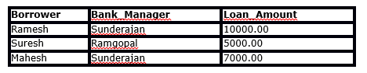  
SELECT Count(*)  FROM  ( (SELECT Borrower, Bank_Manager FROM   Loan_Records) AS S NATURAL JOIN (SELECT Bank_Manager, Loan_Amount FROM   Loan_Records) AS T );

**What is the output of the following SQL query?**

A. 4

B. 5

C. 8

D. 10

**Solution:**

|  |  |  |
| --- | --- | --- |
| BORROWER | BANK_MANAGER | LOAN_AMOUNT |
| Ramesh | Sunderajan | 10000 |
| Ramesh | Sunderajan | 7000 |
| Suresh | Ramgpal | 5000 |
| Mahesh | Sunderajan | 10000 |
| Mahesh | Sunderajan | 7000 |

 “Sunderjan” appears two times in Bank_Manager column, so their will be four entries with Bank_Manager as “Sunderjan”. + Ramgopal, will give 5 strings in sum.

**Q31) Is “SELECT” operation in SQL equivalent to “PROJECT” operation in relational algebra?**

A. Yes, both are equivalent in all the cases

B. No, both are not equivalent

**Solution:**

**Table: AV1**

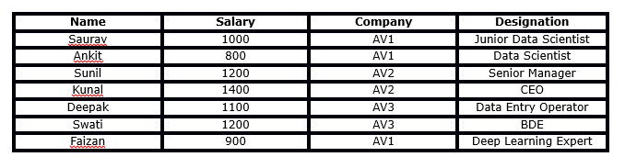

**Questions  32-36 are based on the above table.  
Q32) What will be the output of following query?**

Query 1: Select name from AV1 where name like '%a%'

1. Saurav, Ankit, Kunal, Deepak, Swati, Faizan
2. Saurav, Kunal , Deepak ,Swati , Faizan
3. Kunal, Deepak ,Swati , Faizan
4. None of above

Ans:

Solution:

 The query will search for records in Name, which will have atleast 1 “a” (not “A”).

**Table: AV1**

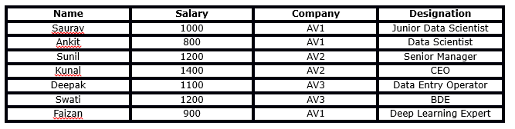

**Q33) What will be the output for the below query?**

Query: SELECT Name from AV1 where Name LIKE '%______%';

**Note: The above operation contains 6 underscores (‘_’) used with LIKE operator.**

A. It will return names where number of characters in names are greater than or equals to 6

B. It will return names where number of characters in names are greater than 6

C. It will return names where number of characters in names are less than or equals to 6

D. It will give an error

**Solution:**

 %_% in LIKE equal 1 any letter in record. 6 “_” in LIKE means, that word must have 6 letter or more.

**Q34) What will be the output of the below query?**

Query: SELECT Company, AVG(Salary) FROM AV1 HAVING AVG(Salary) > 1200 GROUP BY Company WHERE Salary > 1000 ;

A. https://s3-ap-south-1.amazonaws.com/av-blog-media/wp-content/uploads/2017/01/08143626/table-13.png

B.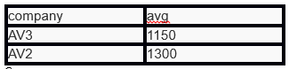

C.

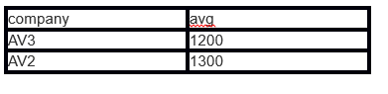

D. None of these

**Solution:**  Query has an error. **Q35) What will be the output for the below Query 1 and Query 2?**

Query 1: SELECT MAX(Salary) FROM AV1 WHERE Salary < (SELECT MAX(Salary) from AV1);  
Query 2: WITH S AS (SELECT Salary, ROW_NUMBER() OVER(ORDER BY Salary DESC) AS RowNum FROM AV1) SELECT Salary FROM S WHERE RowNum = 2;

A. Query 1 output = 1200 and Query 2 output =1200

B. Query 1 output = 1200 and Query 2 output =1400

C. Query 1 output = 1400 and Query 2 output =1200

D. Query 1 output = 1400 and Query 2 output =1400

**Solution:**

 Both queries will take second highest salary (=1200).

**Q36) Consider the following relational schema.**

Students(rollno: integer, sname: string)

Courses (courseno: integer, cname: string)

Registration (rollno: integer, courseno: integer, percent: real)

**Now, which of the following query would be able to find the unique names of all students having score more than 90% in the courseno 107?**

A. SELECT DISTINCT S.sname FROM Students as S, Registration as R WHERE R.rollno=S.rollno AND R.courseno=107 AND R.percent >90

B. SELECT UNIQUE S.sname FROM Students as S, Registration as R WHERE R.rollno=S.rollno AND R.courseno=107 AND R.percent >90

C. SELECT sname FROM Students as S, Registration as R WHERE R.rollno=S.rollno AND R.courseno=107 AND R.percent >90

D. None of these

**Solution:**

Opt B have UNIQUE (command doesn’t using in SQL).  
Opt C will not take unique names to output.

**Q37) Consider the relation T1 (A, B) in which (A, B) is the primary key and the relation T2 (A, C) where A is the primary key. Assume there are no null values and no foreign keys or integrity constraints.**

**Now, which of the following option is correct related to following queries?**

Query 1: select A from T1 where A in (select A from T2)

Query 2: select A from T2 where A in (select A from T1)

A. Both queries will definitely give the same result

B. Both queries may give the same result

C. Both queries will definitely give a different result

D. None of these

**Solution:**

For the same values ( values should be unique) for the column A in tables T1 and T2. Query 1 and Query 2 will give the same output.

**Q38) Which of the following option is correct about following queries?**

Query 1. SELECT emp.id, department.id FROM emp NATURAL JOIN department

Query 2. SELECT emp.id, department.id FROM department NATURAL JOIN emp

A. Both queries will give same outputs

B. Both queries will give different output

C. Need table structure

D. None of these

**Solution:**

For NATURAL JOIN, the order doesn’t matter.

**Q39) Indexing is useful in a database for fast searching. Generally, B-tree is used for indexing in a database. Now, you want to use Binary Search Tree instead of B-tree.**

**Suppose there are numbers between 1 and 100 and you want to search the number 35 using Binary Search Tree algorithm. Which of the following sequences CANNOT be the sequence for the numbers examined?**

A. 10, 75, 64, 43, 60, 57, 55

B. 90, 12, 68, 34, 62, 45, 55

C. 9, 85, 47, 68, 43, 57, 55

D. 79, 14, 72, 56, 16, 53, 55

**Solution:**

 Sorry, pick one randomly.

**Q40) If an index scan is replaced by sequential scan in SQL, then what will happen?**

**Note: Number of observations is equal to 1 million.**

A. Execution will be faster

B. Execution will be slower

C. Execution will not be affected

D. None of these

**Solution:**

Sequential scan is slower, than index scan.

**Q41) Suppose you have a csv file which has 3 columns (‘User_ID’, ‘Gender’, ‘Product_ID’) and 7,150,884 rows. You have created a table “train” from this file in SQL.**

**Now, you run Query 1 as given below and get the following output:**

Query 1: EXPLAIN select * from train where Product_ID = 'P00370853';

**OUTPUT:**

QUERY PLAN  
--------------------------------------------------------------  
Seq Scan on train (cost=0.00..79723.88 rows=16428 width=68)  
Filter: ((product_id)::text = 'P00370853'::text)  
(2 rows)

You have now created Product_ID column as an index in train table using the below SQL query:

CREATE INDEX product_ID ON train(Product_ID)

And, you run Query 2 (same as Query 1) on “train” and get the following output.

Query 2: EXPLAIN select * from train where Product_ID = 'P00370853';

**OUTPUT:**

QUERY PLAN  
-------------------------------------------------------------------------------  
Bitmap Heap Scan on train (cost=829.53..40738.85 rows=35754 width=68)  
Recheck Cond: ((product_id)::text = 'P00370853'::text)  
-> Bitmap Index Scan on product_id (cost=0.00..820.59 rows=35754 width=0)  
Index Cond: ((product_id)::text = 'P00370853'::text)  
(4 rows)

**Which query will take less time to execute?**

A. Query 1

B. Query 2

C. Both queries will take the same time

D. Can’t say

**Solution:**

Query1 – execution time is 79723.88 (in output);

Query2 – time is 40738.85.

**Q42)  Suppose you have a CSV file which has 3 columns (‘User_ID’, ‘Gender’, ‘product_ID’) and 7150884 rows. You have created a table “train” from this file in SQL.**

Now, you run Query 1 (mentioned below):

Query1: EXPLAIN SELECT * from train WHERE product_ID like '%7085%';

Then, you created product_ID columns as an index in ‘train’ table using below SQL query:

CREATE INDEX product_ID ON train(Product_ID)

Suppose, you run Query 2 (same as Query 1) on train table.

Query 2: EXPLAIN SELECT * from train WHERE product_ID like '%7085%';

Let T1 and T2 be time taken by Query 1 and Query 2 respectively. Which query will take less time to execute?

A. T1>T2

B. T2>T1

C. T1~T2

D. Can’t say

Solution:

LIKE command check record, don’t id. Adding product_ID doesn’t help for the query.

**Q43) Suppose you have a table ‘Employee’. In Employee table, you have a column named Salary. Now, you applied Query1 on Employee table.**

Query 1: SELECT * FROM Employee where Salary*100 > 5000;

After that, you created an index on Salary columns and then you re-run the Query 2 (same as Query 1).

Query 2:  SELECT * FROM Employee where Salary*100 > 5000;

Here, Query 1 is taking T1 time and Query 2 is taking T2 time.

**Which of the following is true for the queries time?**

A. T1 > T2

B. T2 > T1

C. T1 ~ T2

D. Can’t say

**Solution:**

Second query will be faster on account of index search.

**Q44) Suppose you are given a table ‘words’. The table has 2 columns ‘id’ and ‘word’.**

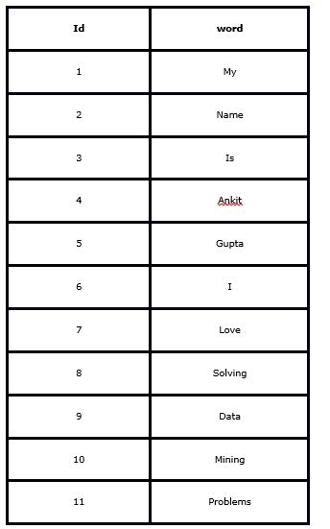

**What will be the output for the below query?**

Query:  select c1, c2, c3 from ( select id,  lag(word) over (order by id) as c1, word as c2, lead(word) over (order by id) as c3 from words ) as t where c2 = ‘Mining’ or c2 = ‘Problems’;

A.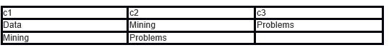

B. Error

C.

https://s3-ap-south-1.amazonaws.com/av-blog-media/wp-content/uploads/2017/01/08144333/table-18.png

D. None of these

**Solution:**

In query is repeat of word from behind column into the next.

**Q45) What is true for ‘View’ in SQL?**

1. It can help in providing security
2. It can be used for hiding complexity
3. If there are more than one table involved in the view, we cannot perform (Data Manipulation Language) DML queries
4. When you drop the base table. View becomes inactive.

Select the correct option:

A. 1 and 3

B. 2 and 4

C. 1, 3 and 4

D. All of these

**Solution:**

**Q46) Suppose I created a table called ‘avian’ using below SQL query:**

Query : CREATE TABLE avian ( emp_id SERIAL PRIMARY KEY, name varchar);

**Now, I want to insert some records in the table avian:**

Query1: INSERT INTO avian (name) VALUES(‘FRAZY');

Query2: INSERT INTO avian (name) VALUES(‘ANKIT');

Query3: INSERT INTO avian (name) VALUES('SUNIL');

Query4: INSERT INTO avian (name) VALUES('SAURAV');

**Which of the following will be the output of the below query?**

Query: Select * FROM avian;

A.

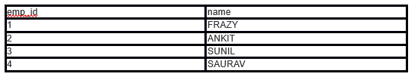  
B.

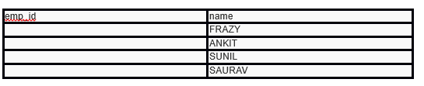

C. Error

D. None of these

**Solution:**

SERIAL make sequence of numbers for emp_id.